 **Phase 1** 

|  |  |  |
| --- | --- | --- |
| Name | ID | Group |
| Salma Hossam Eldein | 20206031 | S5 |
| Mariam AbdelAzaim Hussin | 20206150 | S5 |
| Maryam Khamis Elkadi | 20206160 | S5 |

1. ***GitHub link :-***

<https://github.com/SalmHossam/Sw_Maintenance_Project>

1. ***Jira Link :-***

<https://maintenancephase1.atlassian.net/jira/core/projects/FIRST/board>

1. ***Static Analysis :-***

**Steps we follow to use SonarQube “Static Analysis code”**

* Run command that appeared in SonarQube to compile and build project

Then it BUILD SUCCESS

* We opened SonarQube on <http://localhost:9000> this screen appered with analysis for code

* The overview of code and it was with 993 bugs

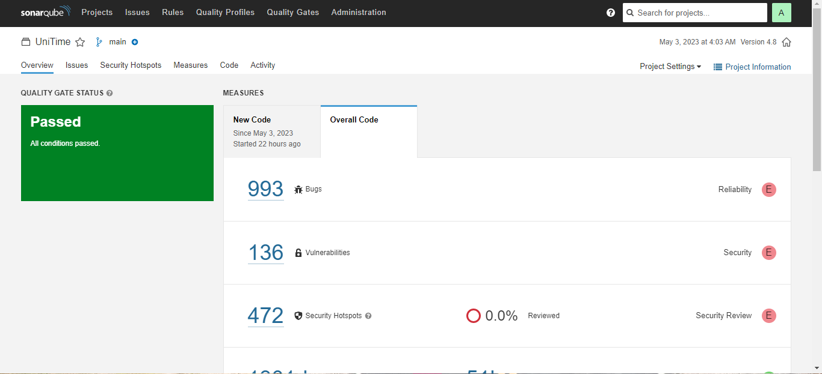

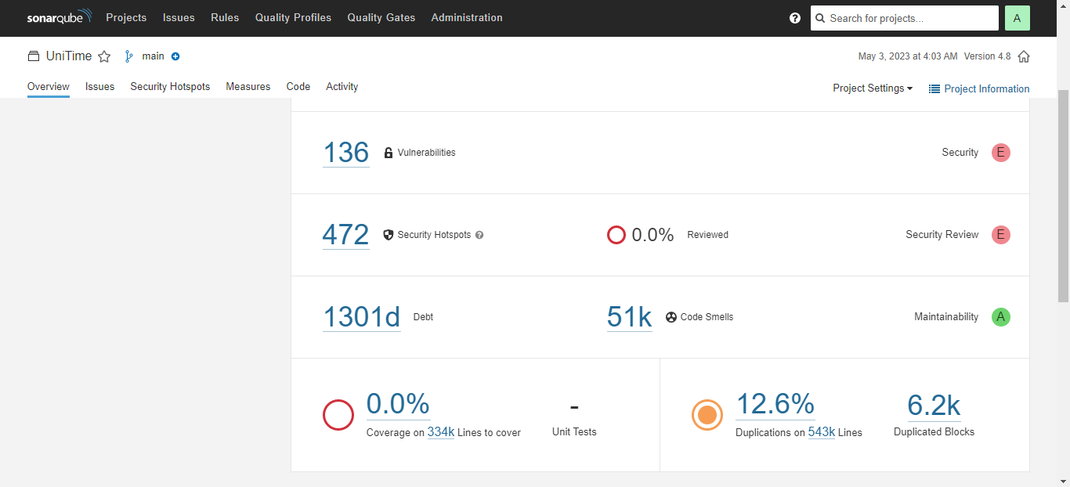

* List of all Bugs in the system

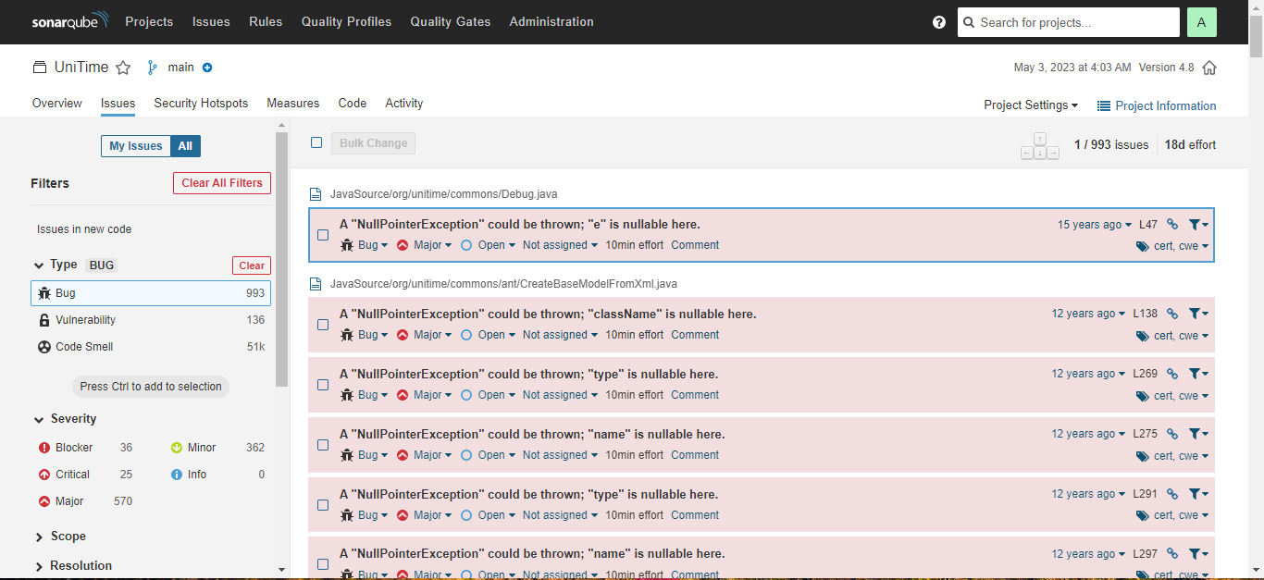

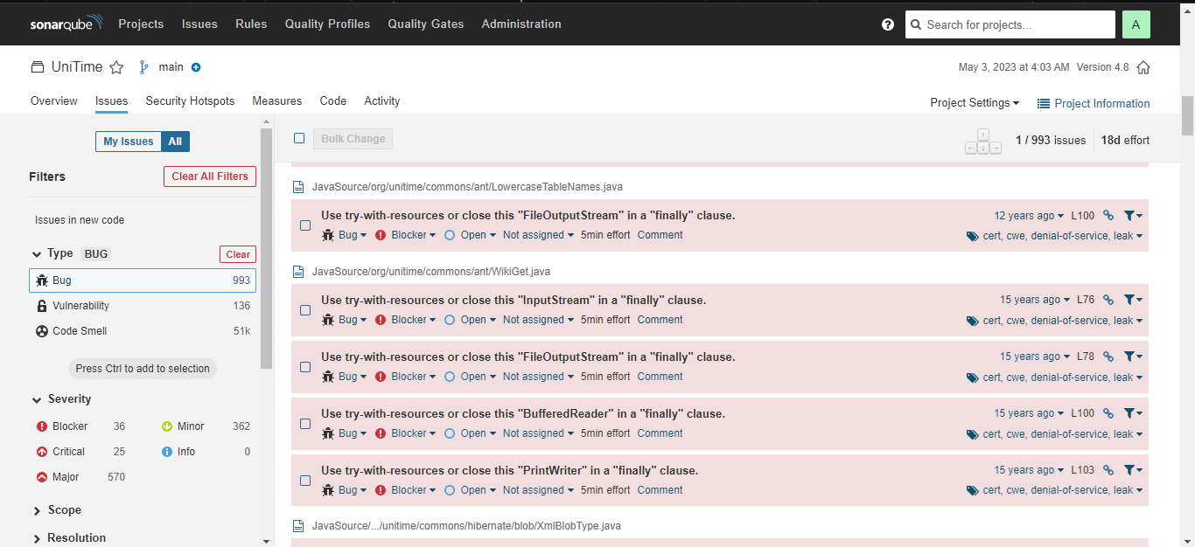

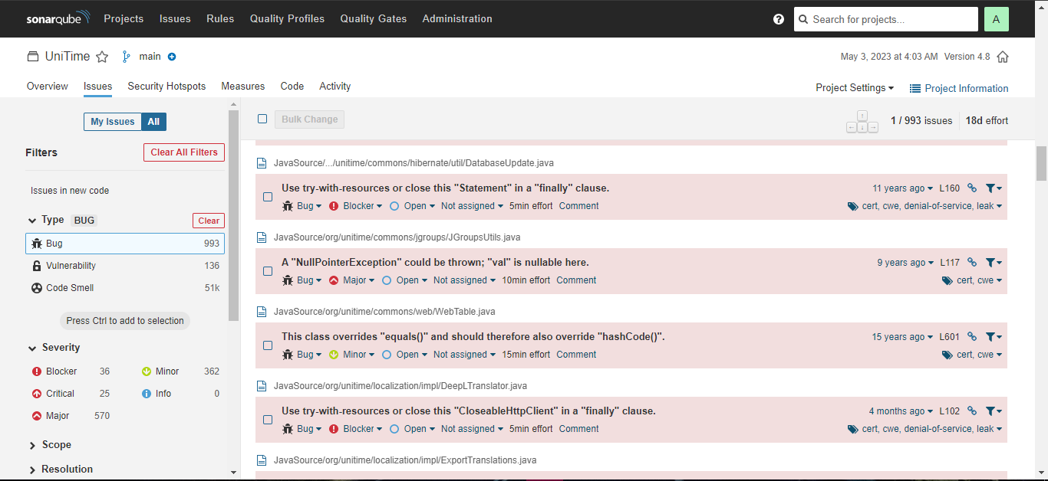

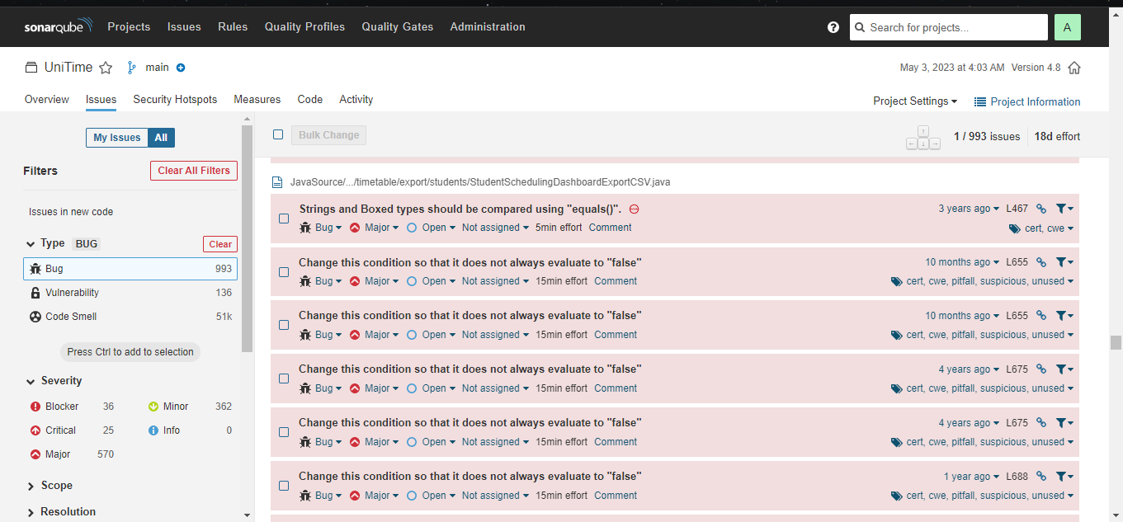

* Vulnerabilty in the code

* some of code smells in the code

* Mesures of the code

* Code Analysis

1. ***Description :-***

We used opportunistic technique

we first look to the features of program then we look to the classes of program and functions.

UniTime is a comprehensive educational scheduling system that supports developing course and exam timetables, managing changes to these timetables, sharing rooms with other events, and scheduling students to individual classes. It is a distributed system that allows multiple university and departmental schedule managers to coordinate efforts to build and modify a schedule that meets their diverse organizational needs while allowing for minimization of student course conflicts. It can be used alone to create and maintain a school's schedule of classes and/or exams, or interfaced with an existing student information system

1. ***Description of features/fix bug:-***

* Class Email:
* We add the forwerd as a new feature to ease to communicate with users.
* Add report new feature to make users report there issues
* Add feedback new feature to get the impression of users on the program .
* Class General HTML:-
* Add text as a new feature to make users write any text.
* Add lable as a new feature to increase the usability.
* Add button as a new feature to increase the usability.
* Class table:-
* Add columns in the table .